School RSE audit tool
This audit tool is designed to help assess your school environment and how it supports comprehensive relationships and sexuality education (RSE).
Using the audit tool
The audit tool can be used by teachers, administration staff, parent committee representatives, and/or health committee members. The key areas and initiatives that support comprehensive RSE are outlined so that they can be coded using a traffic light system to identify areas of strength and areas for improvement.
The audit tool is not an exhaustive list and there may be additional activities that your school does that you may want to include.
Completing the audit tool is a starting point. After collecting and recording the information in the audit tool the next step is to prioritise the areas for improvement in order of importance.
Don’t try to tackle every issue at once. Once priority area/s or issue/s have been identified it is a good idea to establish a working group and develop an action plan. Some useful resources include:
- What is a Health Promoting School (WA Health Promoting Schools Association)
- Making every school a health-promoting school – Implementation Guidance (WHO)
The audit tool can be used to establish a baseline and to monitor progress across years to meet strategic targets.
Health Promoting Schools Framework
The audit tool is based on the principles of the Health Promoting School Framework.
A Health Promoting School is one that uses a health promoting schools approach (or whole school approach). The Health Promoting Schools Framework considers the broad health needs of all school community members and is constantly strengthening its capacity as a healthy setting for living, learning and working.
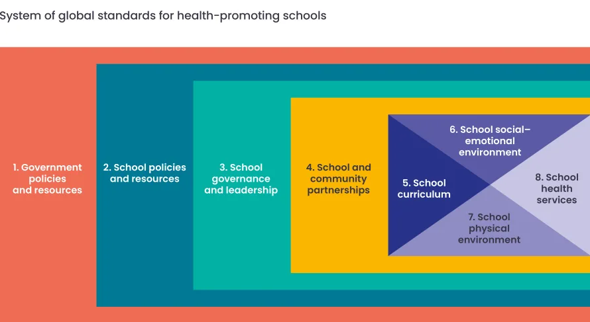
Health needs are addressed collaboratively using a combination of strategies linked to the three interrelated components. The RSE audit tool is separated into these three components as outlined in the diagram.
Environment
School organisation, ethos and environment
Environment considerations include the school policies and philosophical support for the health curriculum, approaches to health and wellbeing, school community relationships and the school’s physical environment.

Not implemented Partially implemented Fully implemented
Baseline Assessment  Date: | Key activity | Date: | Date: | Date:
 | The school ensures that RSE is embedded in the school’s values and moral framework.
 | The senior leaders give RSE high status within the school.
 | There is clear senior management support for comprehensive RSE.
 | There is a named subject leader for RSE.
 | RSE is resourced in line with other subjects, for example being allocated preparation and planning time and resourcing and training budget.
 | The school has an RSE policy agreed by the school board and staff that was developed in consultation with students and parents and is regularly reviewed.
 | The policy links to and is consistent with other policies in the school.
 | The school has developed policies and critical incident plans e.g., image-based abuse incidents.
 | The school has implemented broader RSE related policies and procedures including staff, students and the school community e.g., domestic and family violence, sexual harassment, bullying, sexual behaviour in children and young people.
 | School staff have access to, and are made aware of, various supports for their own health and wellbeing e.g., counselling services, Employee Assistance Program.
 | All students are given opportunities to comment on RSE policy and practice in the school and their views contribute to curriculum planning and evaluation of effectiveness.
 | The diverse experience of students (e.g., vulnerable children, special educational needs and disabilities, LGBTI) are acknowledged and their RSE needs are met.
 | There is a space within the school which students can access to relax and take some time-out.
 | Support and health services available at the school to support students and the wider school community are integrated into comprehensive RSE (school psychologist, counsellor, chaplain, youth worker, school health nurse etc.).
 | Staff model and provide a comfortable environment for students and colleagues to discuss RSE topics openly to help reduce stigma.
 | Opportunities are provided within the school for students, staff, parents and carers, and community members to be involved in RSE outside of the classroom e.g., RSE information on school social media and newsletters, RSE message and poster display, students groups/clubs/committees, marking days of celebration and remembrance (i.e., Sexual Health Week, NAIDOC Week, International Day Against Homophobia, Biphobia, Intersexism and Transphobia (IDAHOBIT), International Day of Friendship).
 | Inclusive language is used throughout the school, including in newsletters and other correspondence.
Partnerships
Partnerships and services
Partnerships considerations include family consultation and involvement, community based programs, the development of strong community links to the school and accessing local services.

Not implemented Partially implemented Fully implemented
Baseline Assessment  Date: | Key activity | Date: | Date: | Date:
 | The school keeps up to date with local health, information and support services and provides clear access to information about them for students.
 | Where appropriate, the school offers school-based drop-ins and other support services for students.
 | The school collaborates with local services/community organisations e.g., stalls at health festivals/fetes, ‘show bags’ with RSE information and resources, presentations or workshops from external agencies.
 | School health and support services (e.g., school health nurse, school psychologist) are informed and involved with RSE programs.
 | Network with neighbouring schools and feeder schools to share information about RSE and explore opportunities for collaboration.
 | RSE policies are communicated with parents, carers and the school community.
 | Parents and carers are consulted and provided with genuine and accessible opportunities to comment on policy and practice.
 | The school recognises that parents and carers are crucial to the success of the RSE program and gives them regular information about RSE program activities and initiatives e.g., letters home, GDHR take home activities.
 | Parents and carers are provided with opportunities to engage with the RSE e.g., parent survey on current RSE knowledge, opportunity to attend sessions with students, invitation to attend events or celebrations.
 | Parents and carers are provided with information and resources in fulfilling their role as educators about relationships and sexuality at home e.g., Talk soon. Talk often, courses, workshops, information nights.
 | RSE related information is included in the school newsletter, social media, website and other community platforms e.g., a list of useful websites, local services.

Education
Curriculum, teaching and learning
Education considerations include the formal content of lessons, pedagogy, resources, formal and incidental learning, professional development and the sequential, scaffolded nature of programs.

Not implemented Partially implemented Fully implemented
Baseline Assessment  Date: | Key activity | Date: | Date: | Date:
 | RSE is an identifiable part of the HPE curriculum, which has planned timetabled lessons across all year groups.
 | RSE is integrated into the overall curriculum and learning areas other than HPE e.g., Maths – statistics; Humanities and Social Sciences – consent laws, marriage equality, gender equality; English – books, plays, movies and media analysis; Science – reproduction, infection, immunisation.
 | School staff have access to and are encouraged to use evidence informed and best practice lessons and programs e.g., GDHR.
 | Assessment opportunities are built into the RSE lessons and program. These assess skills, attitudes and behaviours as well as on knowledge and involve the students reflecting on their own learning
 | RSE is taught by staff who want to teach it, who are trained and supported, knowledgeable and confident.
 | Guest speakers/educators are used to support and enhance RSE not as a replacement to school staff teaching it.
 | The school ensures teachers, school staff and school board members are supported to access RSE professional development and receive ongoing support.
 | Health education strategies, resources and information are communicated and promoted to school staff e.g., staff noticeboard, meetings.
 | Adequate specific budget for RSE resources and professional development is provided.
 | Evidence informed resources are carefully selected for their suitability and reviewed for effectiveness once in use e.g., take an inventory of the RSE resources in the school, cull out-dated resources, promote the suitable available resources, and purchase new to address gaps; share resources and feedback with neighbouring schools.
 | Students feels safe in RSE lessons, for example through the use of group agreements.
 | RSE lessons are inclusive and utilise a variety of teaching and learning strategies to meet student learning needs, encourage the participation of all students and provide opportunities for students to develop critical thinking and relationship skills.
 | Students, teachers, school staff and parents and carers are given opportunities to provide input into RSE lessons and programs.
 | Parents and carers receive information about students’ learning in RSE

