Dear Parents/Carers
This activity is designed for you to complete with your teenager.
Aim: To better understanding the laws around sexting and what someone can do if an image they have sent is shared without permission (consent).
'Sexting' is the sending of nude, semi-naked, provocative or sexual photos, messages or videos. These are sometimes known as 'sexy pics' or 'noodz'. They are also known in legal terms as sexually explicit images or messages, or intimate images. Sexting can be via phone message, social media, online game chat and other online activities.
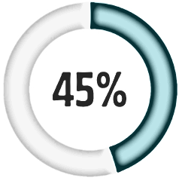
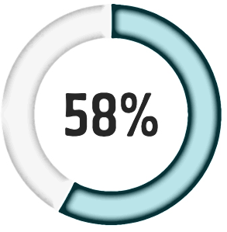
In a 2018 survey of Western Australian Year 10-12’s, in the past 2 months¹:

received a written sext sent a written sext
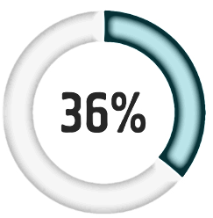
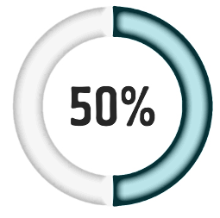
received received a nude/nearly nude sent a nude/nearly nude of themselves

Read Youth Law Australia - Image-based abuse
Read Government of Western Australia – WA’s intimate image laws: frequently asked questions.
List 3 actions (including places to access) you can take if you have received a sext.
Do these new laws make sexting illegal in WA? Explain your answer.

What is the most important thing you have learnt from doing this work on Sexting?
Who will you share this information with?

Having read through the FAQs about the new laws what do you think about them?
In your view do you think they will be effective? Why?
Will they stop people sharing images? Why?

Further information about sexting can be found at:

Office of the eSafety Commissioner- Sexting: What do I need to know?

Office of the eSafety Commissioner- Image based abuse

Youth Law Australia - Sexting

Alarmed (54sec video)

Get the Facts - Sexting

1. Fisher Fisher, C. M., Kauer, S., Waling, A., Bellamy, R., Ezer, P., Kerr, L., Brown, G. & Lucke, J. 2019. Western Australian Survey of Secondary Students and Sexual Health 2018, Bundoora: Australian Research Centre in Sex, Health & Society, La Trobe University.

