Diagram of tampon

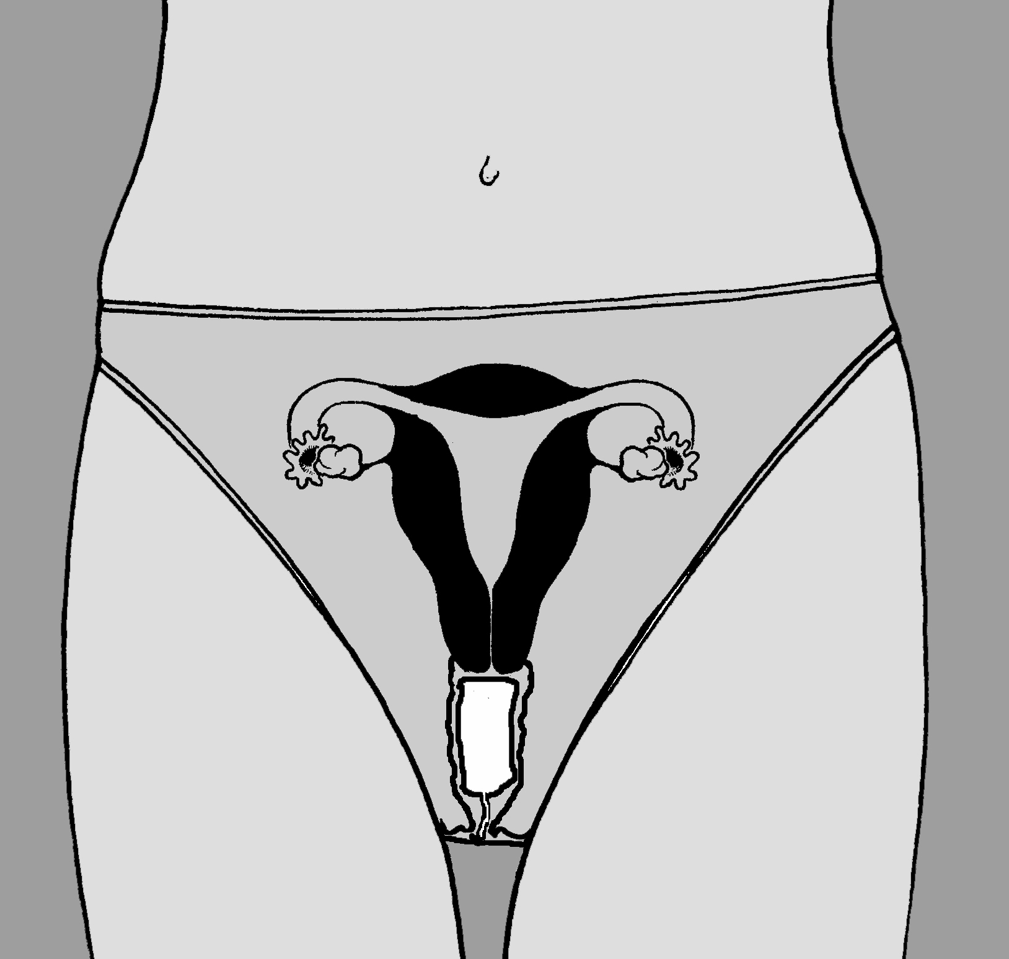

Diagram of pad

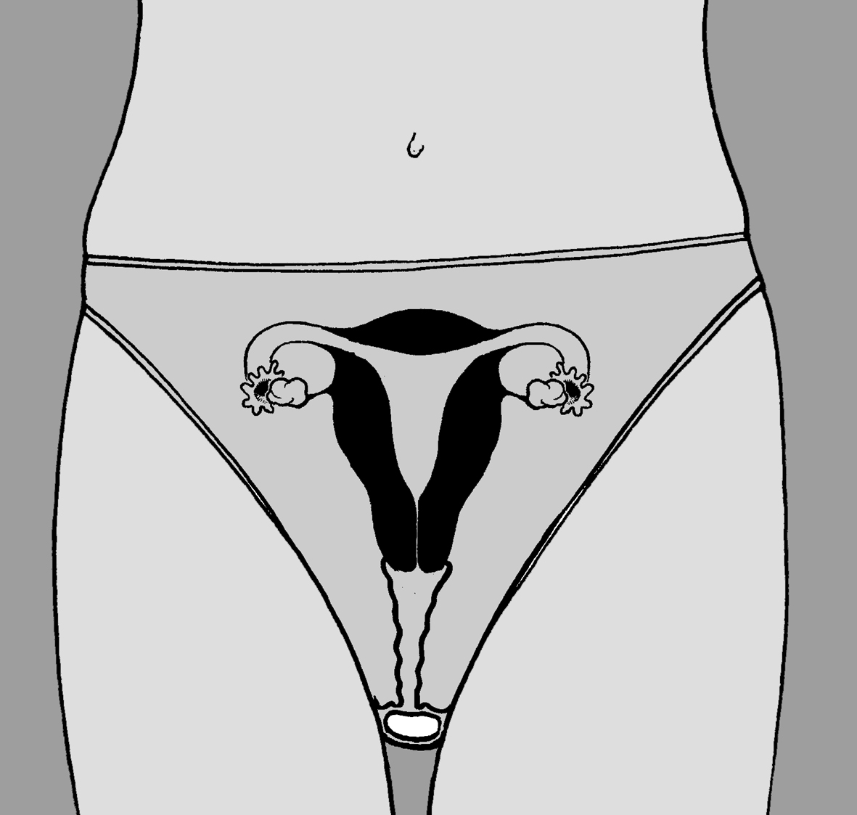

Hints & Tips

- Tampons are safe to use. The cervix is strong and will ensure tampons will not get lost.
- Change regularly (to avoid smells and toxic shock syndrome).
- Don't flush down the toilet... no matter how tempting it is!
- Wear dark coloured underwear.
- Use night or maternity pads with wings when sleeping.
- Use tampons for swimming.
- Rinse blood stains out of clothing and sheets with COLD water as soon as possible (hot water sets the blood).

