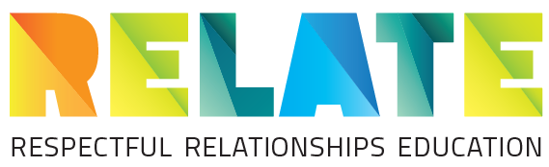  Western Australian Curriculum Mapping  Health and Physical Education Syllabus Year 8  Covered Partially covered | Being healthy, safe and active |  |  |  |  |  | Communicating and interacting for health and wellbeing |  |  | Contributing to healthy and active communities
 | The impact of physical changes on gender, cultural and sexual identities (ACPPS070) | Ways in which changing feelings and attractions form part of developing sexual identities (ACPPS070) | Strategies for managing the changing nature of peer and family relationships (ACPPS071) | Communication techniques to persuade someone to seek help (ACPPS072) | The reasons why young people choose to use or not use drugs (ACPPS073) | Skills and strategies to promote physical and mental health, safety and wellbeing in various environments, such as: assertive responses; stress management; refusal skills; contingency plans; online environments; making informed choices  (ACPPS073) | The impact bullying and harassment can have on relationships, including online relationships, and the health and wellbeing of themselves and others (ACPPS074) | Personal, social and cultural factors influencing emotional responses and behaviour, such as: prior experience; norms and expectations; personal beliefs and attitudes (ACPPS075) | Sources of health information that can support people who are going through a challenging time (ACPPS076) | Health promotion activities which target relevant heath issues for young people and ways to prevent them (ACPPS077) | Benefits to individuals and communities of valuing diversity and promoting inclusivity, such as: respecting diversity; exploring how the traditions, foods and practices of different cultures enhance the wellbeing of the community; challenging racism, homophobia, sexism and disability discrimination; researching how stereotypes and prejudices have been challenged in various contexts (ACPPS078; ACPPS079)
1a. Establishing a group agreement To provide students with an opportunity to explore and discuss factors that make for a safe and supportive learning environment for all.
1b. KWL To revise concepts of Stage 1, to remind students of appropriate language; recognise prior knowledge of students; to give students an opportunity to record what they would like to find out about gender, respectful relationships, communication and sexting.
2. Gender not sex To help students understand the difference between ‘sex’ and ‘gender’ and to recognise gender stereotypes.
3. Respect – What’s OK and what’s not OK? To revise what a respectful relationship is; To identify examples of respectful and disrespectful relationships in the film Tagged.
4. Four questions To identify a framework for considering the safety and respect of people in a situation.
5. What’s the status? To identify the impact of online behaviour on individuals and others in relationships; To apply the 4 Questions framework in situations regarding online messages.
6. Who said what? To revise and apply knowledge of communication styles; to reflect on personal communication styles.
7. Telling stories To review and apply the concepts of being an ethical bystander, respectful relationships, assertive communication, 4 questions framework.
8. Helpful websites To determine the appropriateness and reliability of online health information; to critically analyse a health website.

