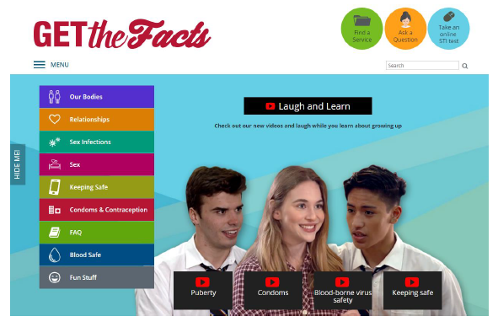

www.getthefacts.health.wa.gov.au/fun-stuff/laugh-and-learn

Video title  and duration | Suggested year levels and GDHR topics | HPE Curriculum links | Take home messages
Puberty Part 1  2:45min | Years 7 & 8  Growing bodies  Emotional wellbeing  Diversity | Being healthy, safe and active (7)  Management of emotional and social changes associated with puberty through the use of:  - coping skills  - communication skills  - problem-solving skills and strategies  Being healthy, safe and active (8)  The impact of physical changes on gender, cultural and sexual identities | Puberty is the period of time when your body changes from a child to an adult. There is a wide range of normal when it comes to the physical changes of puberty.  Puberty positivity – it’s not something to be scared of!
Puberty Part 2  2:20min  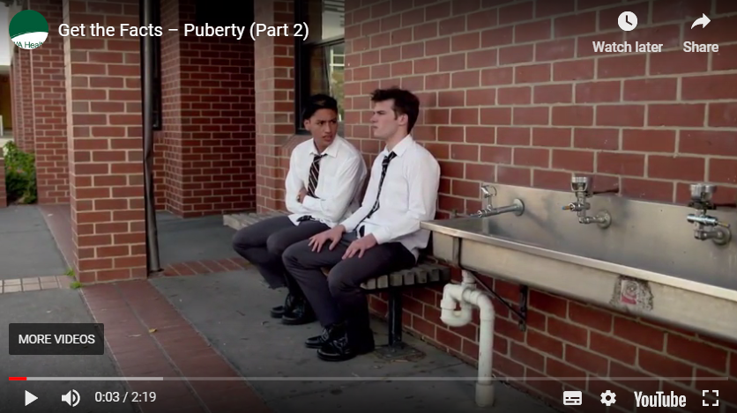 | Years 7 & 8  Growing bodies  Emotional wellbeing  Diversity | Being healthy, safe and active (7)  Management of emotional and social changes associated with puberty through the use of:  - coping skills  - communication skills  - problem-solving skills and strategies  Being healthy, safe and active(8)  The impact of physical changes on gender, cultural and sexual identities | Puberty positivity – positives of puberty and ways to cope with the challenges associated with puberty.  Emotional and social changes of puberty and how to manage them.
Condoms  2:23min | Years 9 & 10  Staying safe  Respectful relationships  Emotional wellbeing | Being healthy, safe and active (9)  Skills to deal with challenging or unsafe situations:  - refusal skills  - initiating contingency plans  - expressing thoughts, opinions, beliefs  - acting assertively | Safer sex means using a condom to prevent pregnancy and STIs.

Video title  and duration | Suggested year levels and GDHR topics | HPE Curriculum links | Take home messages
BBVs safety  1:47min  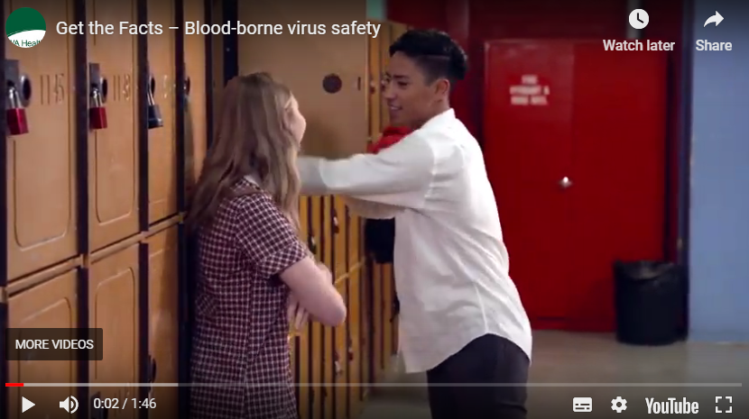 | Years 9 & 10  Staying safe  Respectful relationships  Emotional wellbeing | Being healthy, safe and active (9)  Actions and strategies to enhance health and wellbeing in a range of environments  Skills to deal with challenging or unsafe situations:  - refusal skills  - initiating contingency plans  - expressing thoughts, opinions, beliefs  - acting assertively  Being healthy, safe and active (10)  Skills and strategies to manage situations where risk is encouraged by others | BBVs can be transmitted through blood to blood contact (needles, sex, tattoos).  Use a condom when having sex. Don’t share needles.  Get piercings/tattoos from reputable places that use safe blood practices.
Keeping safe  2:08min  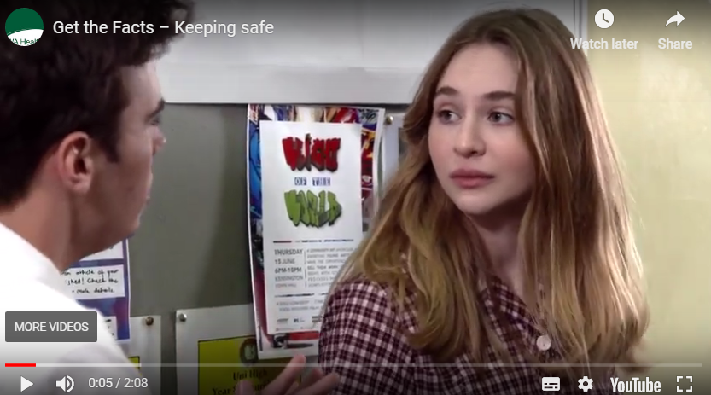  Additional Video:  Wanna have sex? Consent 101 (external site)  5.55min | Years 9 & 10  Staying safe  Respectful relationships  Emotional wellbeing | Being healthy, safe and active (9)  Skills to deal with challenging or unsafe situations  Actions and strategies to enhance health and wellbeing in a range of environments  Impact of external influences on the ability of adolescents to make healthy and safe choices  Communicating and interacting for health and wellbeing (9)  Characteristics of respectful relationships  Being healthy, safe and active (10)  Skills and strategies to manage situations where risk is encouraged by others  External influences on sexuality and sexual health behaviours, including the impact decisions and actions have on their own and others’ health and wellbeing  Communicating and interacting for health and wellbeing (10)  Skills and strategies to promote respectful relationships | Communicating with your partner about readiness for sex, consent and contraception is vital.

