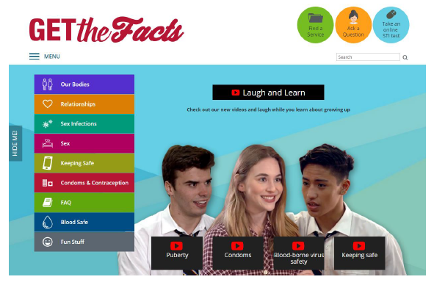

- These lesson plans have been created to accompany the Laugh and Learn videos that can be found on our Get the Facts youth website:
  - Puberty 1
  - Puberty 2
  - Condoms
  - Blood-borne virus safety
  - Keeping safe

- Year levels have been suggested for each of these videos and lesson plans. However, it is appropriate for teachers to use their professional judgment and, after viewing the videos, choose to use them with other year levels in order to fill some of the gaps that may exist in students’ knowledge and understanding.

- In accordance with Department of Education policy it is essential that teachers preview these videos and any suggested resources before showing students or referring to them. Because of the content (e.g. sex, consent, sexual assault) some teachers may find some of the language and concepts not suitable for their students. See page 2 of Use of texts in educational settings guidelines (external link).

- It is essential that teachers know and understand the following strategies for delivering best practice relationships and sexuality education.
- Group agreement for a safe and supportive environment
- Protective interrupting
- Dealing with disclosures and Department of Education: Responding to disclosures (external link)
- Question box

- These resources link to GDHR topics Staying safe, Growing bodies, Emotional wellbeing, Respectful relationships and Diversity. See Curriculum overview for further information.

- With the exception of Puberty 1 and Puberty 2, which need to be implemented sequentially, these videos and accompanying lesson plans can stand alone. However, prior knowledge is assumed and, ideally, these resources support and add value to a well-planned, effective, best practice relationships and sexuality education program.

- Teachers need to be aware of diversity (known and unknown) and understand how language can reinforce gender stereotypes and assumptions. See Background teacher notes: Gender identity and Sexual identity for further information.

- This diversity also extends to the level of experience and engagement in sexual activity that students in one class, group or cohort will have.
- When talking to the group, say “many/some young people know …” rather than “everyone has…” or “everyone knows…”.
- Do not assume that ALL young people in your group have engaged in ‘sexual activity’ or ‘had sex’. La Trobe University’s 2018 National survey of Australian secondary students and sexual health (NSASSH) research indicated that 34% of Year 10s, 34% of Year 11s and 50% of Year 12 students had engaged in sexual intercourse (vaginal and/or anal). 74% had experienced some form of sexual activity.

- Clarify ‘sexual activity’ – it is open to interpretation and has a wide range of connotations for many people. La Trobe University’s 2018 NSASSSH research reports 74% of secondary school students in the sample had experienced some form of sexual activity: i.e. deep kissing; touching a partner’s genitals; being touched on genitals; giving or receiving oral sex; engaging in anal sex; engaging in sexual intercourse (with or without a condom).

- While there are many resources available online that address these topics it is NOT advisable to ask students to Google these topics for more information or resources. All website links in this resource have been chosen because they are from reliable and credible Australian government or health agency sources, and specifically target young people, teachers and/or parents.

- Relationships and sexuality education can be a sensitive topic to teach. For important information about considering values and values teaching strategies see:
- Exploring my own values
- Developing values

- Suggested or possible answers are provided in italics.

