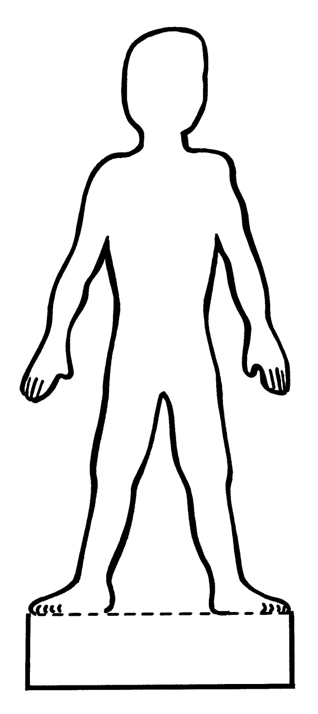

Photocopy this sheet and cut out each label.

Neck

Head

Arm

Leg

Heart

Stomach

Bottom

