## Overview

The word 'puberty' is derived from the Latin word pubertas, meaning adulthood. It is the transition period that takes a person from being a sexually immature child to a sexually mature adult.  It usually involves a growth spurt, appearance of secondary sex characteristics, reproductive fertility and profound psychological changes. The pace of this growth and change are second only to that of infancy. The ages at which these changes begin, and their rate of growth, vary enormously.

### When does puberty happen?

Up until around the age of 8, there is little physical difference between boys and girls. In girls or people with ovaries, puberty usually starts at about 8-13 years. In boys or people with testicles, puberty usually starts a little later at around 9-14 years of age. People who are intersex may go through puberty later than this or may not go through puberty at all without medical intervention. (See: [Gender Diversity](https://gdhr.wa.gov.au/-/gender-diversity/12.0) for more information on intersex.)

The trigger for puberty is the production of hormones in the brain which travel to the testicles/ovaries. The ovaries begin to release the hormones oestrogen and progesterone. The testicles begin to release the hormone testosterone. Once these sex hormones are released, changes in the body begin and secondary sex characteristics begin to appear. These changes can take place over a number of years (usually about 2-5 years).

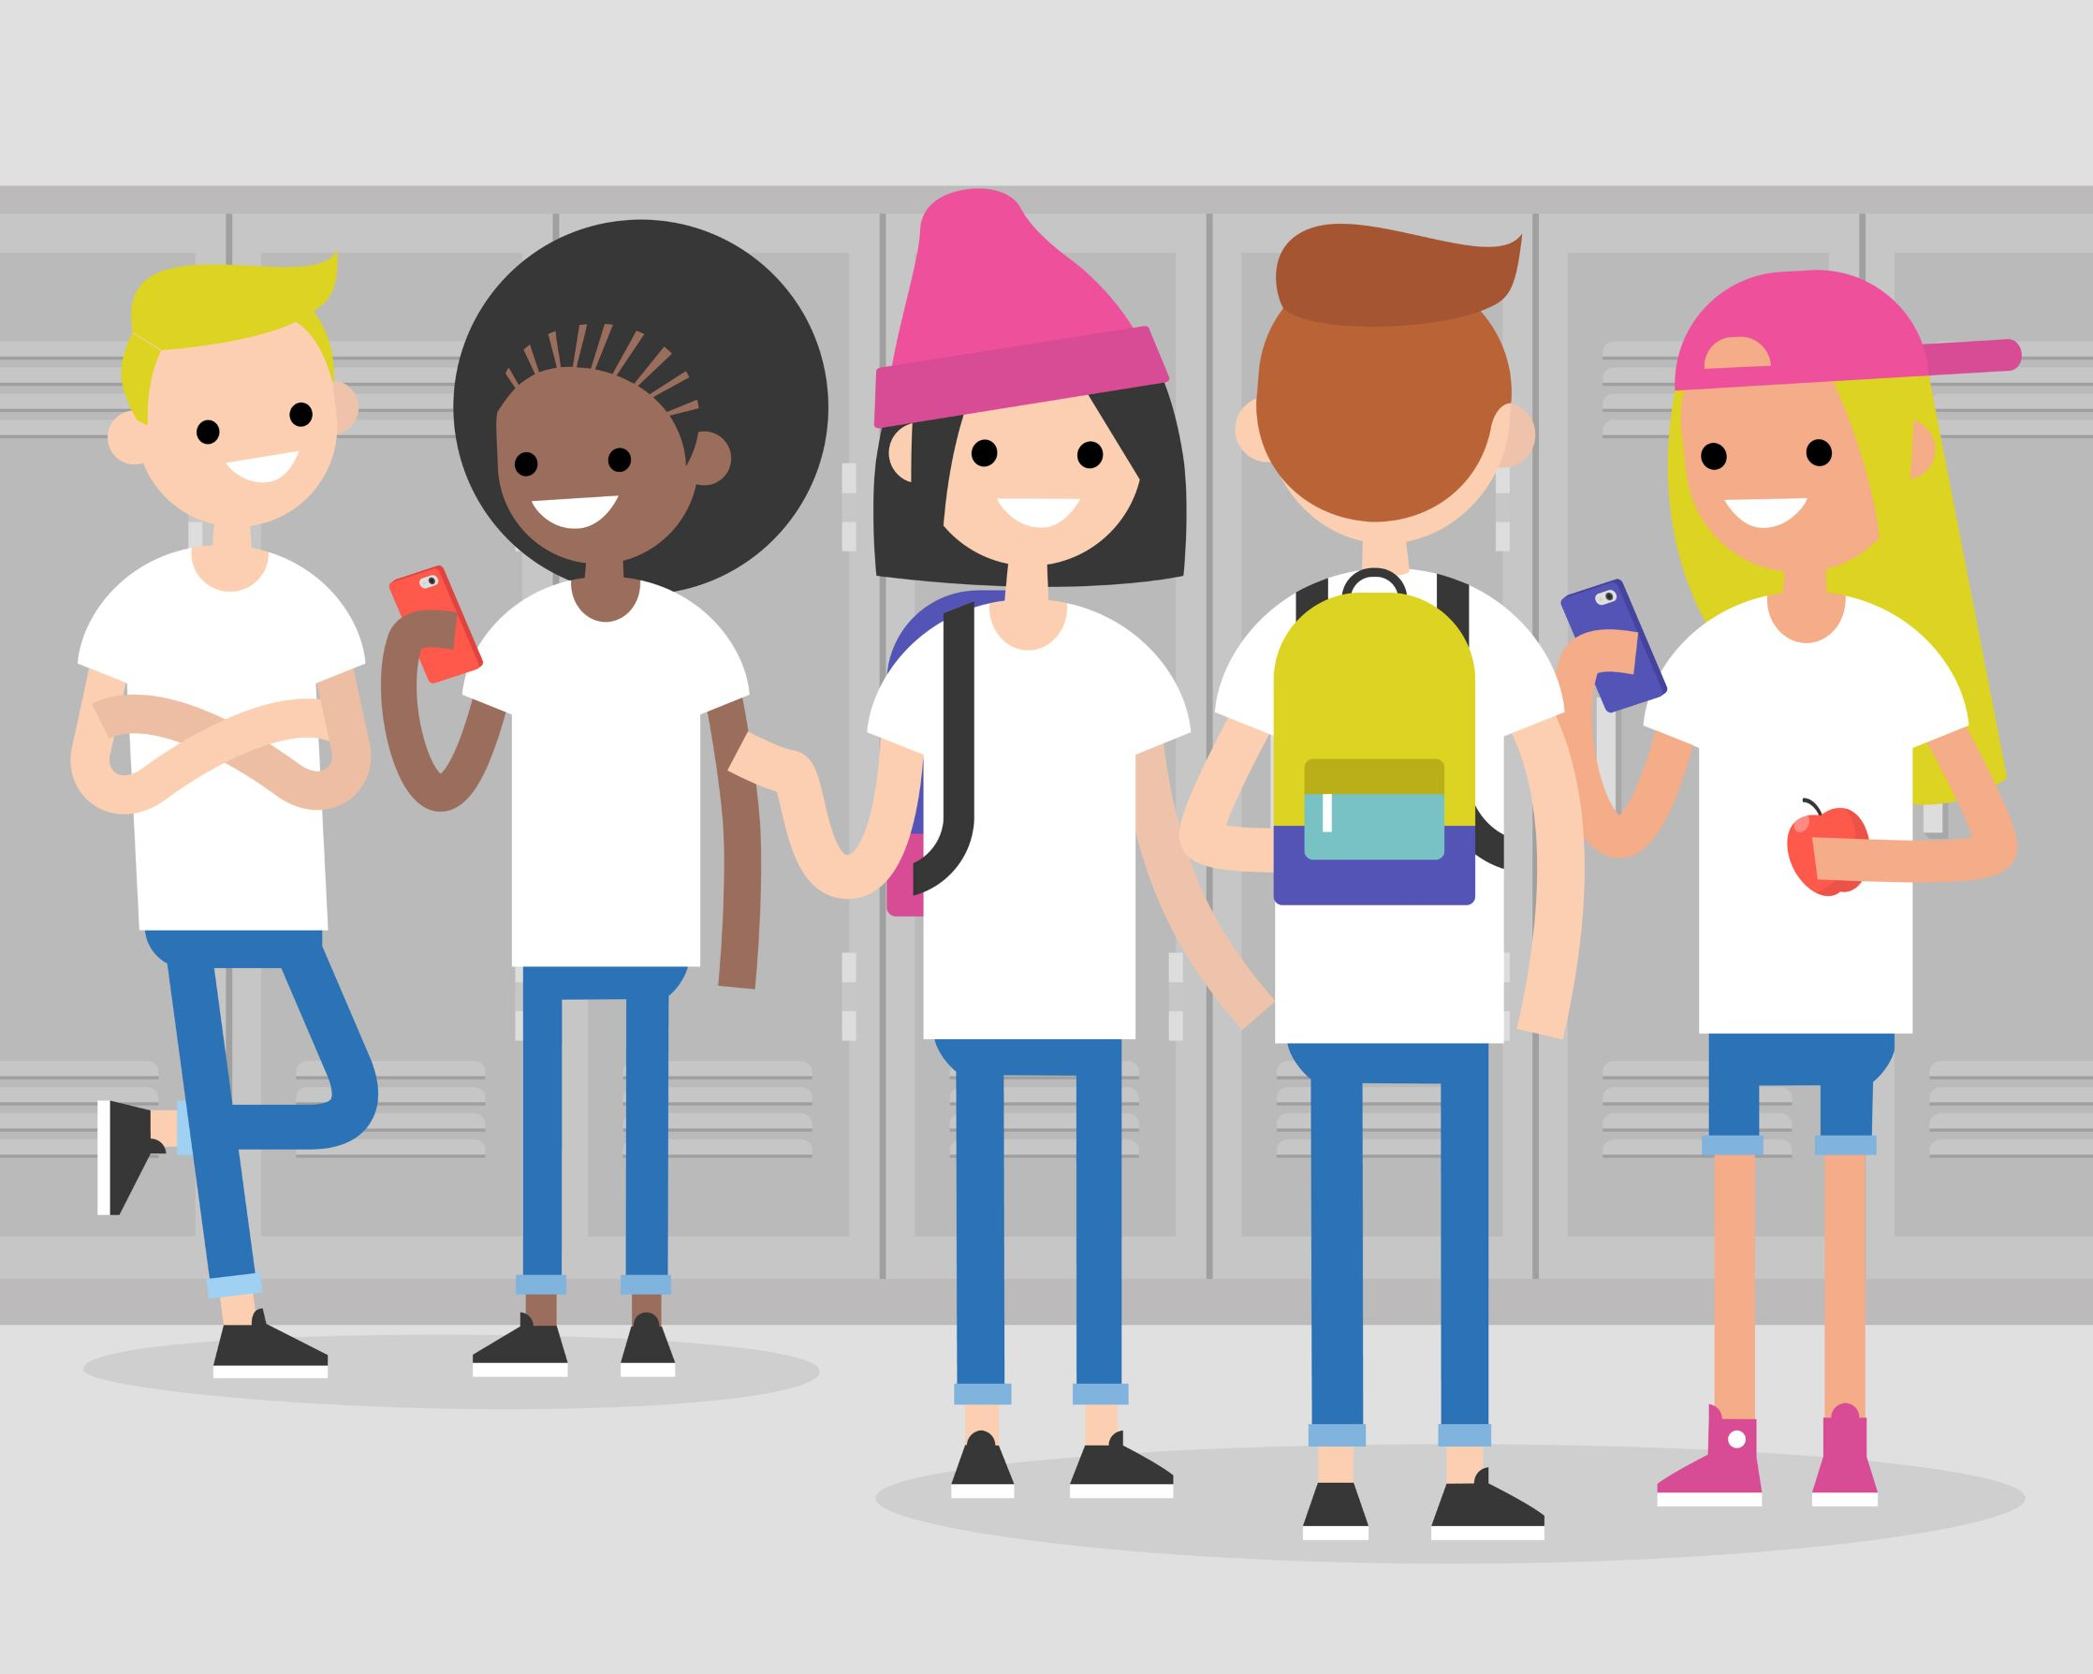

### Changes during puberty

During puberty people go through physical, social and emotional changes. Some of these changes happen mostly to boys or people with testicles, some happen mostly to girls or people with ovaries, and some usually happen to everyone. There are a number of intersex variations that can lead to different experiences during puberty.

### Physical changes

Mostly girls (or people born with ovaries/uterus/vulva)

* hips get broader (growth of fatty and supporting tissue on hips and buttocks and enlargement of pelvis)
* shoulders may get a bit broader
* body shape generally becomes more rounded and body fat increases
* breasts develop (many different shapes and sizes and it is normal for two sides to be different)
* pubic hair
* face and body hair increases (but generally less than for boys). It is also normal for girls to have a few hairs around their nipples.
* voice can deepen but it is generally not as noticable as for boys
* vagina and uterus grow larger
* vulva becomes larger - outer lips (labia majora), inner lips (labia minora) and clitoris
* vaginal discharge at times - small amount of whitish discharge which is normal, healthy and helps keep the vagina clean
* menstrual cycle begins
  + Roughly once a month the lining of the uterus gets thick with blood ready to nourish a pregnancy.
  + If no pregnancy occurs, the lining breaks down and passes out the vagina (approximately a couple of tablespoons, but can look like more).
  + This is called a period or menstruation and it usually lasts 3-7 days.
  + Periods may be irregular at first but usually become more regular over time.
  + First periods usually start about 10-14 years of age.

Mostly boys (or people born with testicles/penis)

* shoulders get broader
* breasts may swell a bit (this usually only lasts a few months)
* generally get more muscular
* hair on chest and facial hair (the amount of body hair varies greatly)
* voice 'breaks' and becomes deeper (may go up and down - squeaky to deep, before settling down)
* the 'Adam's apple' (larynx cartilage) gets bigger
* testicles and penis grow larger (penises are all different shapes and sizes)
* reproductive organs mature and start to produce sperm and semen
* erections may happen more often (penis gets hard when spongy tissue inside fills with blood). Erections can feel good but sometimes they just happen and can feel awkward
* ejaculation - with the production of sperm, first ejaculation may happen as a 'wet dream' or through masturbation
* wet dreams (when an ejaculation/release of semen happens during sleep)

Usually everyone

* gets taller (skeletal growth)
* may put on weight (this usually settles as they get older)
* body shape changes
* pubic hair grows
* hair under the arms grows
* hair on legs and arms grows or thickens
* skin and hair get oilier (sweat gland production)
* pimples (and acne for some people)
* body odour noticeable and sweat more (may need to shower and change clothes more regularly, may want to use deodorant)
* may start masturbating or masturbate more (touching or rubbing of the genital area for pleasure). Masturbation is a private thing. It is completely normal to masturbate (and also completely normal not to).

Although the timing of pubertal changes varies greatly, the sequence of pubertal changes is relatively predictable.

For people born with 'female' genitalia, the first sign of puberty is usually the start of breast development. This is followed by a growth spurt, pubic hair growth and a change in body shape with hips widening. Menstruation usually starts about 2 years after the first signs of breast development.

For people born with 'male' genitalia, the first sign of puberty is usually the testicles getting larger. This is usually followed by pubic hair and the penis growing larger. The voice deepening usually happens at about the same time as the growth spurt, broadening of shoulders and muscle development. Growth of facial hair is usually later in puberty.

### Emotional changes

Adolescence is a time of maturation, however, the biological, social, emotional and intellectual growth in an adolescent is not synchronised. Emotional changes can be impacted by these disconnected rates of growth.

Most young people go through puberty fairly smoothly, and each person is different. Some common emotional changes during puberty may include:

* changes in how they feel about themselves (and everything else in their life)
* mood swings (partially due to hormone activity)
* increased stress, frustration and anxiety
* being more sensitive
* having feelings of self-consciousness about their changing bodies (and comparing their bodies to friends and those seen in media)
* becoming more independent
* starting to formulate their own values systems.

### Social changes

Some of the social changes during puberty may include:

* young people beginning to detach from family and seeking more independence
* changes in relationships with friends and family
* friendships becoming very important and adolescents becoming more influenced by peers
* feelings of sexual attraction (may be to same or other sex)
* developing romantic or intimate relationships
* becoming sexually active.

See also [Adolescent relationships](http://gdhr.wa.gov.au/-/adolescent-relationships).

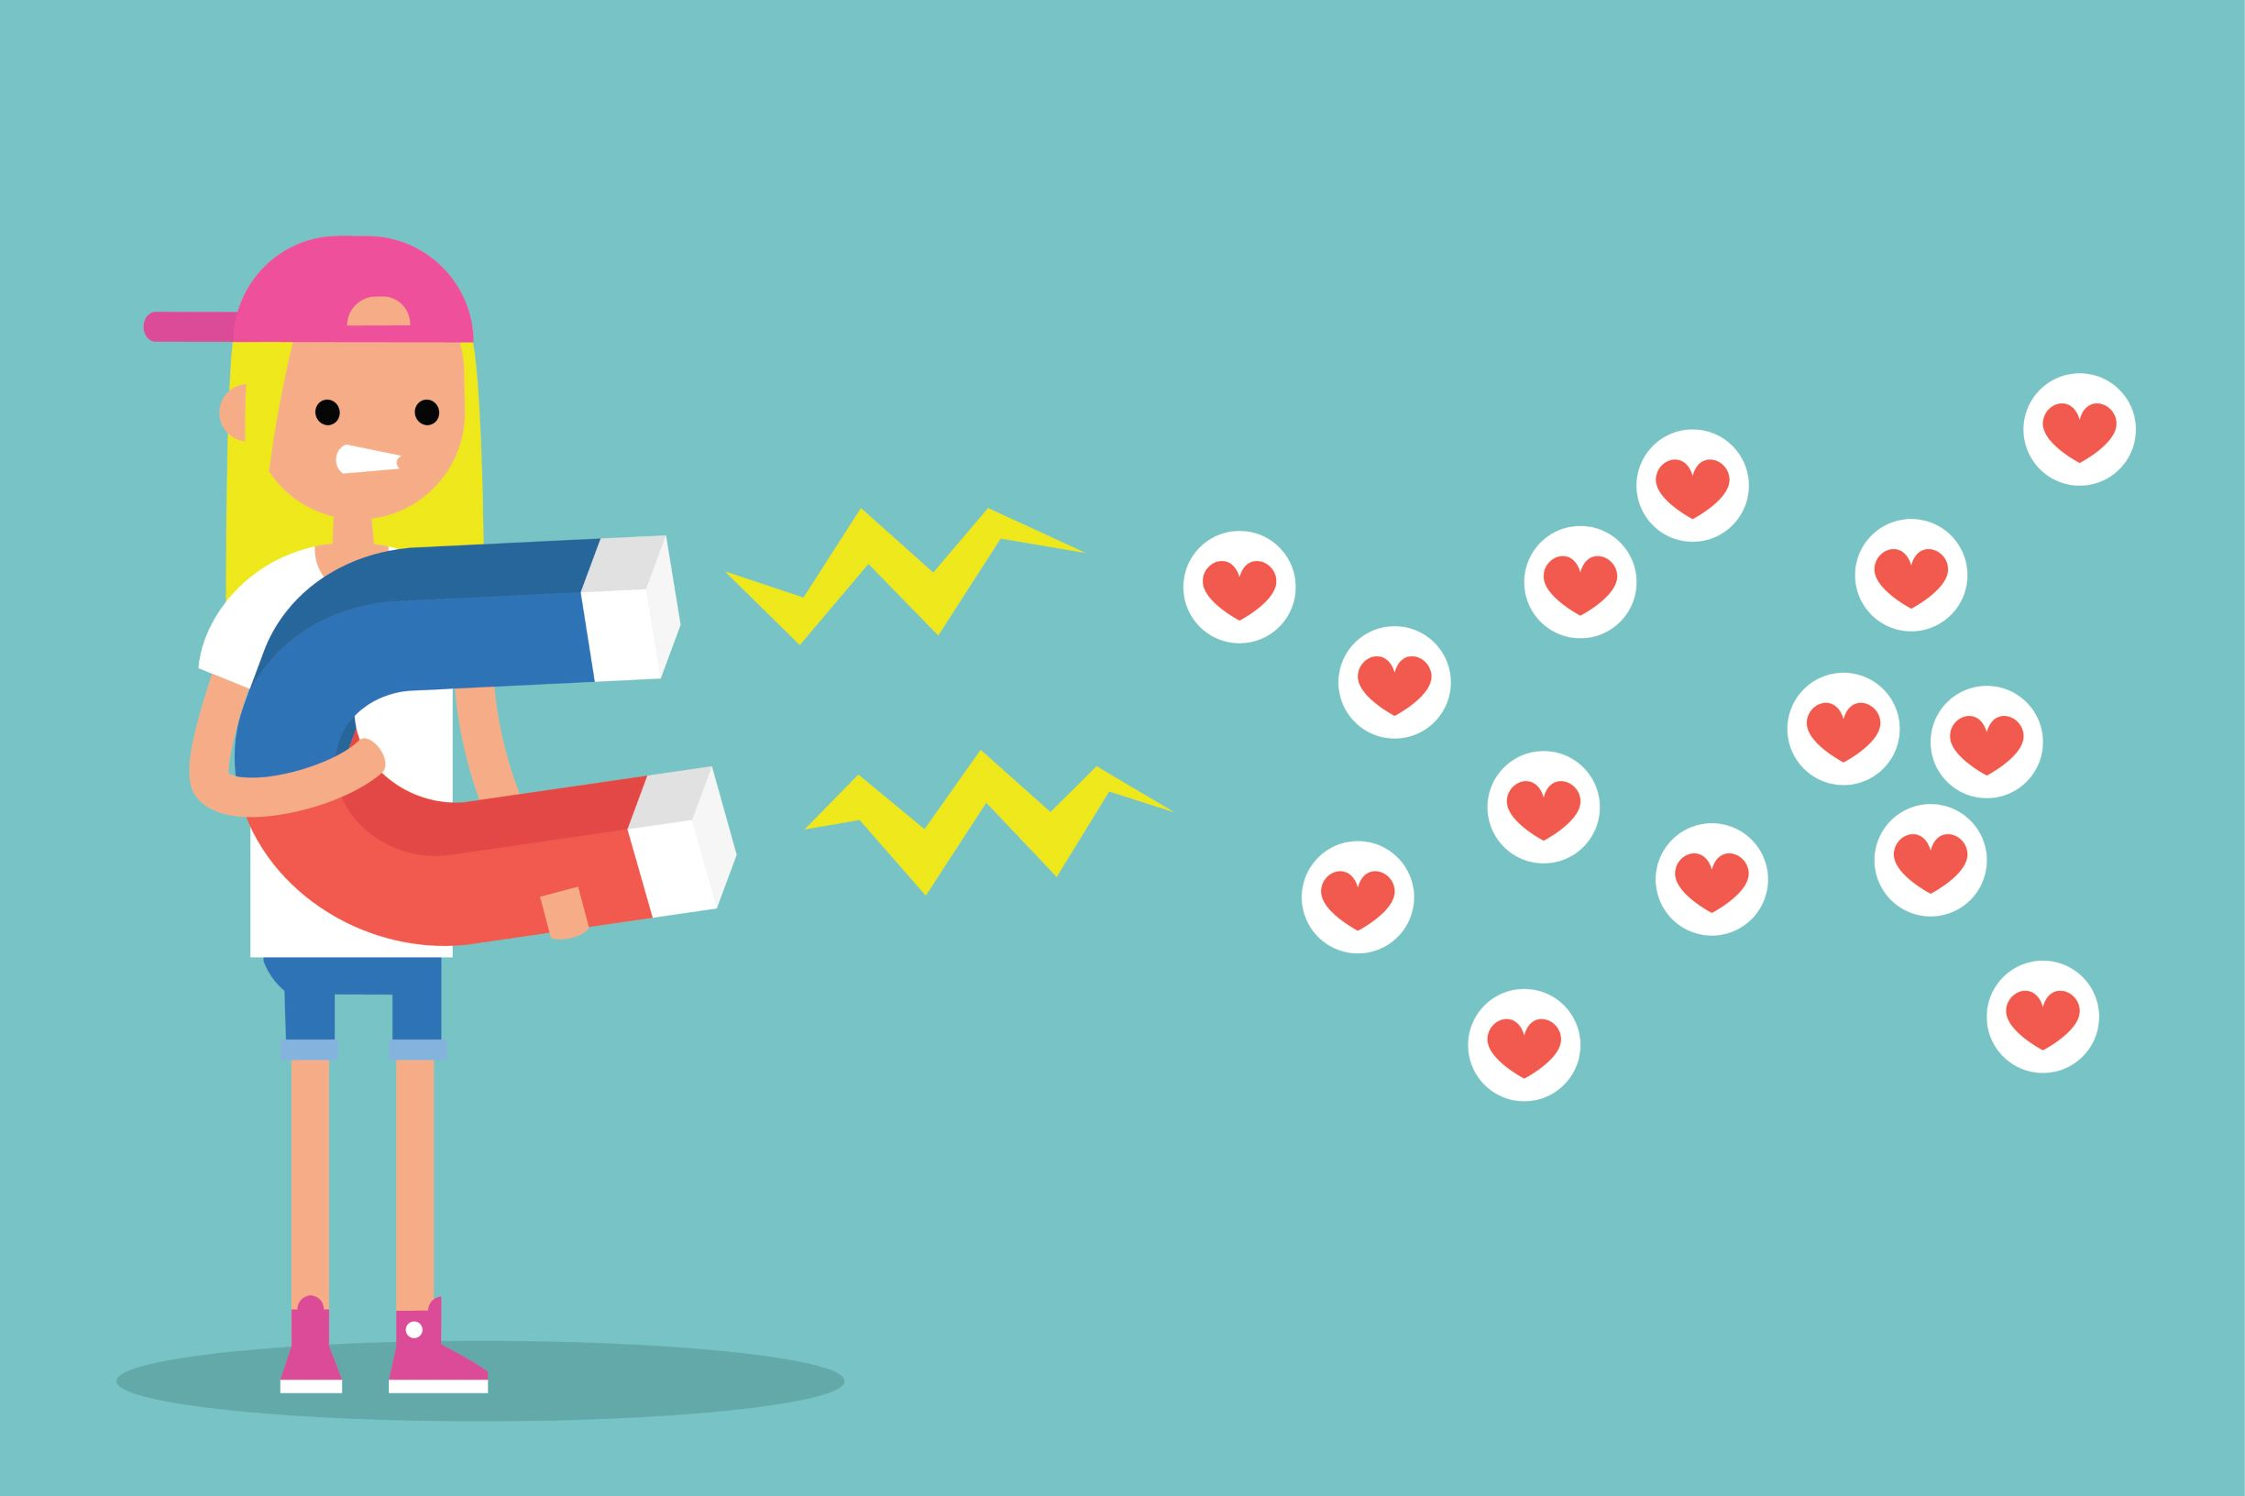

### Gender diversity and puberty

Not everybody who is born with ovaries, a uterus or a vulva identify as a girl or woman. Not everybody who is born with testicles or a penis identifies as a boy or man.

People who are transgender or gender diverse may find puberty a particularly stressful time if their bodies start to develop characteristics that do not match their true gender. For people who have intersex variations, puberty may happen later or they may not experience all of the usual parts of puberty. For some intersex people, they will not go through puberty unless they have hormone replacement therapy.

It is estimated that between 1.2% and 4% of Australian young people are gender diverse or transgender and approximately 1.7% have intersex variations.1 2 3 It is important for teachers to be aware of the possible diversity in their classroom (and that this diversity may not be 'visible' to them. See Teaching Tips below for ways to help make puberty lessons more inclusive for gender diverse young people.

See [Gender diversity](https://gdhr.wa.gov.au/-/gender-diversity/12.0) for more information.

### Key messages for young people

* Puberty is the time when the body changes from a child to an adult. These changes usually mean that a person is physically able to have a baby.
* There is a wide range of 'normal' when it comes to puberty - everyone's body is different and should be respected.
* Girls (or people born with ovaries/uterus) usually start puberty between 8-13 years. Boys (or people born with testicles) usually start puberty between 9-14 years.
* Puberty happens over a number of years (usually about 2-5 years).
* There are some changes that happen mostly to boys (or people with testicles/penis) and others that happen mostly to girls (or people with ovaries/vulva). Some changes usually happen to everyone.
* Changes during puberty can be physical, emotional and social.

### Teaching tips

* Puberty and RSE programs should be a partnership between the home and the school.
* It is vital for young people to know about the changes to expect during puberty before they begin. Puberty lessons may not start in schools until upper primary when some children are already starting puberty. Send parents copies of [Puberty](https://gdhr.wa.gov.au/-/puberty-booklet) and [Talk Soon. Talk Often](https://www.healthywa.wa.gov.au/Articles/S_T/Talk-soon-Talk-often) when their child starts at your school so that they can introduce the topics at home. You can send reminders to them to look at them when you start your RSE program.
* Ensure parents are informed that puberty and other elements of relationships and sexuality education will be covered in class. Parents may need reassurance that 'sex education' is not about 'teaching their child to have sex' and includes topics such as puberty, respect, hygiene, decision-making, safety, etc.
* Parental permission is not required to teach anything that is part of the curriculum. However, parents do need to be informed of any 'controversial topics or content' under [Department of Education Policy: Use of texts in educational settings](http://det.wa.edu.au/policies/detcms/policy-planning-and-accountability/policies-framework/guidelines/use-of-texts-in-educational-settings.en). Parents and guardians may request exemptions from any lessons in writing under [Department of Education Policy: Exemption from particular classes guidelines.](http://det.wa.edu.au/policies/detcms/policy-planning-and-accountability/policies-framework/guidelines/exemption-from-particular-classes-guidelines.en?cat-id=3457121)
* Offer parent workshops or information evenings and encourage students to talk to their parents about what they are learning about in school.
* The topic of puberty may be an exciting and interesting topic for some and others may feel embarrassed, uncomfortable or even worried about learning about puberty. It is vital to have a [group agreement](https://gdhr.wa.gov.au/guides/what-to-teach/establishing-ground-rules) in place to create a safe space for learning.
* Part of having a safe space for learning is having a classroom with sufficient privacy. Students may feel self-conscious and disengage if other students or staff are able to see inside the room or enter the room unexpectedly during RSE lessons.
* It is important to be mindful of the diversity of bodies. Some people have disabilities, injuries or illnesses that mean their bodies may look and function in different ways. Everyone has a body that deserves resepct.
* Puberty can be a particularly challenging time for people who are gender diverse and people who have intersex variations. Being mindful that some lessons may be triggers for young people and ensure that you have created a safe space with a [group agreement](https://gdhr.wa.gov.au/-/teaching-ti-2) in place.
* Try to use inclusive language. Using words that are not absolute can go a long way to helping all people to feel more included (not just people who are transgender or intersex). Use words like ‘most’, ‘many’ and ‘some’ instead of ‘all’ or ‘everyone’. Regular reminders that there is a wide range of ‘normal’ helps too. For example,
  + "Most people with a uterus will get their period during puberty".
  + "Puberty can start as young as 8 for some people, for some it may not start until 16. Most people start puberty around 10 or 11."
  + "Most people will then be able to make a baby."
* Student comfort levels can be increased by introducing the topic with fun energisers that promote safe touch and group collaboration. Hands-on, creative and collaborative activities remove the pressures that individual activities and written activities can create. See [Teaching Strategies](https://gdhr.wa.gov.au/learning/teaching-strategies) and [Learning Strategies](https://gdhr.wa.gov.au/learning/learning-activities) for lots of ideas.

If you using an educational or multimedia resource, minimise possible student distraction by using current and not obviously out of date (ie. clothes, hair styles and quality) videos. Always view content in full before determining the suitability for your students (this is a requirement of [Department of Education policy](http://det.wa.edu.au/policies/detcms/policy-planning-and-accountability/policies-framework/guidelines/use-of-texts-in-educational-settings.en)). Allow sufficient time for discussion afterwards.

* Teachers sometimes ask whether it's preferable to separate boys and girls for these classes. There are pros and cons for both but ultimately teachers and schools are best placed to decide what is best for their students specific needs. See [FAQ:](https://gdhr.wa.gov.au/web/guest/-/should-boys-and-girls-be-separated-for-sex-education-) *Should boys and girls be separated for puberty and sexual health lessons?* for a list of considerations. Also see  [Background teacher notes](https://gdhr.wa.gov.au/guides/background-notes/-/asset_publisher/unUlu2t85YV3/content/co-ed-or-gender-segregated-lessons-?_com_liferay_asset_publisher_web_portlet_AssetPublisherPortlet_INSTANCE_unUlu2t85YV3_assetEntryId=707009&_com_liferay_asset_publisher_web_portlet_AssetPublisherPortlet_INSTANCE_unUlu2t85YV3_redirect=https%3A%2F%2Fgdhr.wa.gov.au%2Fguides%2Fbackground-notes%3Fp_p_id%3Dcom_liferay_asset_publisher_web_portlet_AssetPublisherPortlet_INSTANCE_unUlu2t85YV3%26p_p_lifecycle%3D0%26p_p_state%3Dnormal%26p_p_mode%3Dview%26_com_liferay_asset_publisher_web_portlet_AssetPublisherPortlet_INSTANCE_unUlu2t85YV3_cur%3D0%26p_r_p_resetCur%3Dfalse%26_com_liferay_asset_publisher_web_portlet_AssetPublisherPortlet_INSTANCE_unUlu2t85YV3_assetEntryId%3D707009): *Co-ed or gender segregated lessons?*
* Ensure students understand the key messages listed above.
* 'Puberty kits' can be a useful tool in the classroom. These can consist of samples (or pictures) of tampons, pads, menstruation cups and underwear, deodorant, shavers, soap, etc. These kits can be for demonstration or free samples can be acquired to give students 'take home packs'.
* Free samples of menstruation products can be obtained from various companies, for example:
  + [Libra: Starter kits](https://lovelibra.com/libra-girl/starter-kits/) and [free samples](https://lovelibra.com/au/free-samples/) (external site)
  + [Kotex](https://www.ubykotex.com.au/free-samples) (external site)
  + [Carefree](https://www.becarefree.com.au/products/request-sample) (external site)
* The free [SECCA app](https://app.secca.org.au/) has been designed for people with with special educational needs and has over 2000 images to support RSE including images for learning about puberty.
* It is important for young people to know that puberty changes can take some time to get used to and that there are lots of people and places to go for help if they need to talk to someone.
  + Have students think of 5 people (1 for each finger on a hand) that they could go to if they had questions or were worried.
  + Display links to organisations such as: [Kids Helpline](https://kidshelpline.com.au/); [Headspace](https://headspace.org.au/); [Beyondblue](https://www.google.com/url?sa=t&rct=j&q=&esrc=s&source=web&cd=3&cad=rja&uact=8&ved=2ahUKEwiZ3YTZ-a7jAhUKX30KHRWTALgQFjACegQIAhAB&url=https%3A%2F%2Fwww.youthbeyondblue.com%2F&usg=AOvVaw2i1nnn9xboiQfAJ_nSXZ4r); [SHQ Helpline](https://shq.org.au/helpline/).

### Relevant resources

#### Fact sheets/booklets/videos

[Puberty](https://gdhr.wa.gov.au/-/puberty-booklet), WA Department of Health

[Talk Soon Talk Often](https://www.healthywa.wa.gov.au/~/media/HWA/Documents/Healthy-living/Sexual-health/talk-soon-talk-often.pdf), WA Department of Health

[Puberty](https://www.getthefacts.health.wa.gov.au/our-bodies/puberty), Get the Facts

[Puberty animation](https://www.getthefacts.health.wa.gov.au/our-bodies/puberty/puberty-animation), Get the Facts

[Puberty](http://www.sexandu.ca/your-body/puberty/), Sex and U (Canada) (external link)

1. Telfer M, Tollit M, Pace C, Pang K 2018. Australian standards of care and treatment guidelines for transgender and gender diverse children and adolescents. Melbourne: Royal Children’s Hospital.

### Postscript

## This Background Note relates to the following Learning Activities:

* [Reproductive systems](https://gdhr.wa.gov.au/-/reproductive-systems)
* [Puberty kits](https://gdhr.wa.gov.au/-/puberty-kits)
* [Puberty - Managing change and transition](https://gdhr.wa.gov.au/-/managing-change-and-transition)
* [Puberty part 1](https://gdhr.wa.gov.au/-/puberty-part-1)
* [Puberty part 2](https://gdhr.wa.gov.au/-/-laugh-and-learn-videos-puberty-part-2)
* [Reproductive systems revision](https://gdhr.wa.gov.au/-/reproductive-systems-revision)
* [Body changes during puberty](https://gdhr.wa.gov.au/-/body-changes-during-puberty)

### Date printed

28 March 2024