Overview
Improperly using and discarding needles and syringes can increase the risk of transmitting blood-borne viruses such as HIV and hepatitis.

Blood-borne viruses (BBVs)

Blood-borne viruses (BBVs) are viruses that are passed on by blood-to-blood contact when infected blood enters another person's bloodstream. BBVs include:
- Human immunodeficiency virus (HIV)
- Hepatitis C virus (HCV)
- Hepatitis B virus (HBV)
Possible routes of transmission include:
- sharing drug injecting equipment - this includes needles, syringes, water, swabs, filters, spoons, tourniquets and the drug mix.
- tattooing, body piercing and other body art when the equipment is not sterile or when sound infection control practices are not followed.
- sharing personal items such as nail clippers, toothbrushes, tweezers and razors.
- blood-to-blood contact - this may not be obvious and can occur in ways that are indirect. For example, by touching the injecting site of someone with hands that are contaminated with the blood of another person. Blood does not need to be visible for blood cells or virus to be present.
Hepatitis B and HIV are also sexually transmitted. Hepatitis C is not generally considered to be sexually transmitted, but if blood-to-blood contact occurs during sex then transmission is possible.

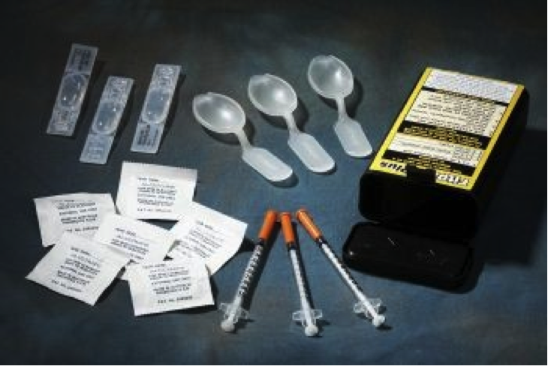

Needlestick injury

A needlestick injury occurs when a person's skin gets punctured or scratched by a used needle. This occurrence carries the risk of transmission of a BBV.
There are two types of needlestick injuries: those that may occur to health professionals in the course of their duties (e.g. drawing blood or injecting medication) and those that may occur in community settings (e.g. beaches and parks) due to improperly discarded needles and syringes.
Needles and syringes improperly discarded in the community may be of concern to the public, however, the risk of contracting a BBV from a community needlestick injury is very low. In Western Australia, there has never been a documented case of a person contracting HIV, hepatitis C or hepatitis B from a needlestick injury in a community setting.

Prevention

- Don't share personal hygiene items such as razors, toothbrushes and dental floss.
- Avoid touching someone who is bleeding unless you are wearing gloves.
- Do not participate in rituals such as 'blood brothers and blood sisters'.
- Before considering any body art (such as tattooing or piercing) make sure the body artist uses only sterilised equipment, and new razors, inks and needles each time.
- Always practice safer sex and use condoms.
- Do not inject drugs. However, if a person does inject drugs then they should never share needles, syringes, filters, water or spoons. Hands should be washed or fingers swabbed before touching another person's injection site. New, sterile needles and syringes should always be used. These are available from most chemists, needle and syringe exchange outlets, and at country hospitals after hours.

What to do if a discarded needle/syringe is found

On school grounds by a student
- Do not be alarmed.
- Do not touch the needle or syringe.
- Report the finding to a teacher (if found at school) or another adult.

On school grounds by a teacher, or outside of school grounds by a student
- Do not be alarmed.
- Get a rigid-walled, puncture resistant, plastic container with a well-secured lid, preferably screw top. Avoid using glass which can shatter, aluminium that can be squashed or frosted plastic that may not be puncture-proof.
- Bring the container to the needle and syringe, and place on the ground next to the needle and syringe. Do not hold the container as you are putting the syringe in it.
- Pick up the used needle and syringe by the blunt end, away from the point. Do not touch the sharp point.
- Do not try to put the plastic protective cap back on a needle if it has been removed.
- Put the needle and syringe point-first into the container. More than one needle and syringe can be placed in the container, but do not overfill. Do not carry the needle and syringe unless it is in a suitable container.
- Make sure the container is tightly sealed.
- Put the sealed container in a domestic rubbish bin. Do not put needles and syringes down toilets, in recycling bins or post boxes.
- If you accidentally prick yourself with the needle, refer to the First Aid Procedure below.
- Do not panic, take reasonable care and follow the above steps. Tell children never to pick up a needle, but to tell an adult.
- If you are regularly finding needles and syringes in a particular area, contact your local government Environmental Health Officer.

First aid procedure

- Where a needlestick injury is suspected, if possible, have the injured person stem his/her own blood flow and clean up the blood spill.
- Immediately wash the infected area gently and thoroughly with mild soap and clean running water for at least 30 seconds.
- Apply antiseptic and a sterile dressing to the wound.
- Place the needle and syringe in a rigid-walled plastic container as described above.
- Take the infected person and bottled needle and syringe to a medical practitioner or emergency department of the local hospital for BBV antibody testing.
- All tests should be conducted within 24 hours of the injury occurring. Taking the bottled needle and syringe may help with documenting the nature and extent of the needlestick injury.

Teaching tips

- Students need to be taught not to touch found needles or syringes. They need to report their find to a teacher (if found at school) or another adult.
- Emphasise the importance of students seeking help from a trusted adult. Have students consider what action they would take if the trusted adult said it was okay for them to touch (without protection) the blood or items that had blood on them. Practise this action within a role play.
- Remind students to take extra care in situations where blood or blood products may be involved. "If you see a needle stay away, tell an adult right away."
- Encourage students not to share toothbrushes, razors, nail clippers or jewellery such as earrings or participate in rituals such as 'blood brothers and blood sisters.
- Discuss that many diseases can be carried in blood or blood products. Mention that these diseases include hepatitis B and hepatitis C which affect the liver. Briefly discuss that for some forms of hepatitis there is no vaccine or cure, however for hepatitis B there is a vaccination which can be given at 12 years of age. There is also a vaccination for hepatitis A for people travelling to high-risk areas such as developing countries (note that hepatitis A is not a blood-borne virus). Currently, there is no vaccination for hepatitis C.

Relevant resources

Fact sheets/booklets/videos
Blood safety, Get the Facts

Postscript

This Background Note relates to the following Learning Activities:

- Blood-borne virus safety

Date printed

29 March 2024

